# Infrastructure Description v2

Infrastructure Integration Roadmap Task

**Task Type(s)**: Coordination  
**Start by phase**: Integration  
**Complete by phase**: Ongoing  
**RP role(s)**: Resource or Service Integration Coordinator, Documentation and knowledge base contact(s),

## Summary

ACCESS infrastructure that is visible to researchers/users, resource providers, developers, between ACCESS projects, or the broader community must be described. ACCESS resource providers, ACCESS projects, and other ACCESS affiliated online service providers (i.e. science gateways, etc.) enter basic information about their organization and then describe the infrastructure that they operate in the Cyberinfrastructure Description Repository (CiDeR). Audience relevant summaries of these descriptions are displayed in different ACCESS websites.

Initial setup involves the integration coordinator obtaining administrator access to CiDeR so they can authorize others in their organization to enter and maintain infrastructure descriptions. This task should take ~½ hour. Organization staff enter initial descriptions and maintain accurate infrastructure descriptions in CiDeR. This task should take ~1 hour/year per infrastructure element.

## Prerequisite tasks

None

## Support Information

For assistance with this task see the *Support Information* section in your *Integration Roadmap Description*.

## Detailed Instructions

Organization staff access CiDeR at <https://cider.access-ci.org/login>.

### Initial CiDeR Setup

If your organization already has CiDeR access, skip to step C.

Submit an *Integration and Operations Request* from [this page](https://operations.access-ci.org/help) with the Title “New CiDeR Organization” and the following information:

* Organization logo URL or attached file
* Organization public URL
* Organization PI/director name
* Organization PI/director email address
* External Data Posting
  + Organization ID Type either [GRID](https://www.grid.ac/) or [RINGGOLD](https://www.ringgold.com/ringgold-identifier/)
  + Organization ID
  + City, State, and Country
* The ACCESS usernames of individuals that will be CiDeR administrators for your organization. These individuals will be able to grant other individuals access to maintain infrastructure descriptions. Persons can be both CiDeR administrators and the maintainers of descriptions.

Submitted organization information will be entered by a CiDeR administrator in a form as shown below and used to grant access to CiDeR administrators.

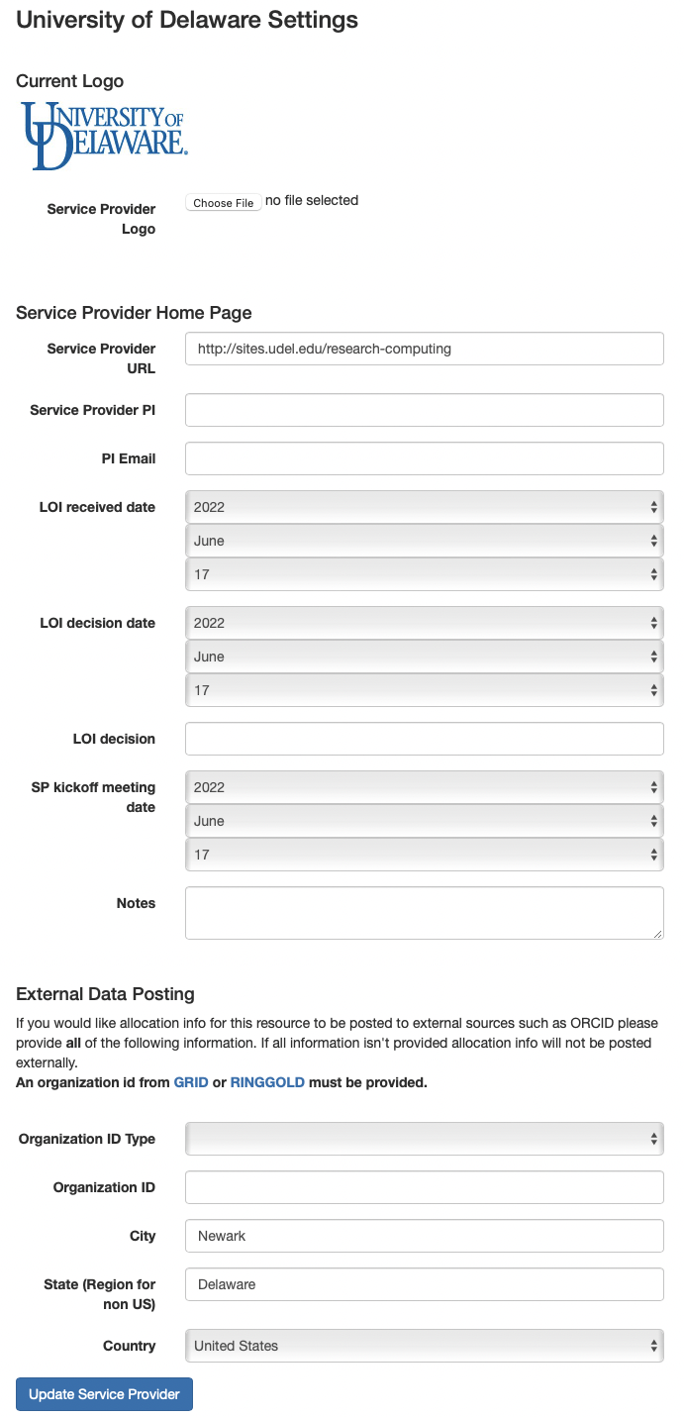

### Provide CiDeR access to other organization staff

After the integration coordinator has been granted CiDeR access they can grant other organization staff access to enter and maintain infrastructure descriptions:

* Select “Service Providers” or “Organizations” along the top.
* Click on your “Organization” name.
* Click on “Administrators”.
* Add additional Organization Admins who may enter and update your organization resource information.

### Enter Infrastructure Descriptions

Organization staff enter new infrastructure descriptions as detailed in the Quick Start Guide and User Guide:

<https://cider.access-ci.org/cider_manual_full.pdf>

Steps:

* Select “Resources” along the top.
* Click on “Add a Resource” to add a new resource, or click on a resource name to edit an existing resource.
* Enter as much information as possible in this first form
* Select Resource Features as follows:

| **Applicable Resource Type** | **Features** |
| --- | --- |
| Compute, Cloud, Storage | Select from the following features: - Sensitive data support - Community software areas for users  - Visualization support  - Advanced reservation support  - Discounted preemptible queue support  - CONECTnet attached  - Internal resource not visible to users |
| Compute, Cloud, Storage | If your resource supports science gateways select features starting with “Science Gateway *”. |
| Online Services | Select from the following features:  - ACCESS Online Services for users  - ACCESS Online Services for resource providers  - ACCESS Online Services for developers  - ACCESS Online Services for ACCESS projects |
| Science Gateway Online Services | This feature designates a registered Online Service as a science gateway:  - ACCESS Integrated Science Gateways |

* Select a “Resource Type” at the bottom of the screen and “Create Resource”
* For Compute, Cloud, and Storage type resources, enter as much information as possible in this second form and the following **minimum required information**:

| **Field Name** | **Applicable Resource Type** | **Notes** |
| --- | --- | --- |
| NodeCount | Compute, Cloud | For cloud record the number of controller nodes. |
| CPUCountPerNode | Compute, Cloud | For heterogeneous clusters use the mean value per node |
| MemoryPerCPUGB | Compute, Cloud | For heterogeneous clusters use the mean value per node |
| PeakTeraflops | Compute | Leave blank if unknown |
| DiskSizeTB | Compute | For heterogeneous clusters use the mean value per node |
| FileSpaceTB | Compute, Storage, Cloud | Total amount of shared storage (network attached and parallel file-system) |

### Enter Resource Conversion Factors

Skip this section if your resource is not ACCESS allocated .

Page 16 of the CiDeR Manual has instructions for entering a “conversion factor”. This is the NU conversion factor of your resource, divided by 21.576. This will be used to compute your initial marketplace exchange rate. **For most compute resources, you should NOT change the conversion factor that you already have listed.**In a later stage of ACCESS, additional tools will be created to manage your variable marketplace exchange rate.

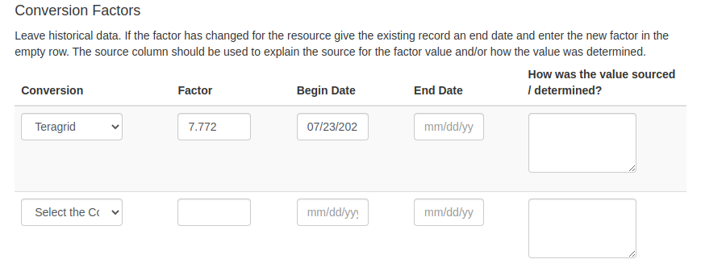

### Maintain infrastructure descriptions

Information in CiDeR must be kept up to date and reviewed for accuracy at least yearly.

## Document Management

**Status**: Official

**Official date**: 2/15/2023

**Coordinators**: JP Navarro, ACCESS Operations; Nathan Tolbert, ACCESS Allocations

**Last revised date**: 2/3/2023

**Retired date**: